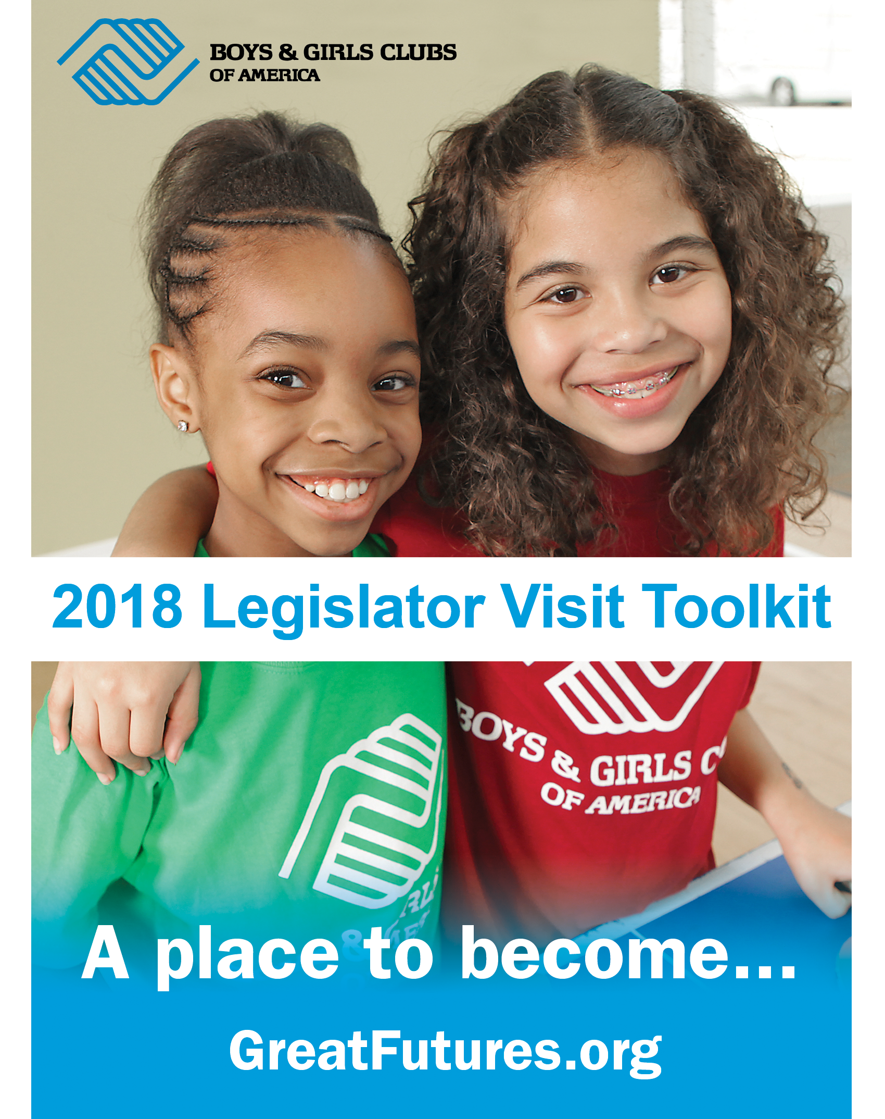

TABLE OF CONTENTS

Introduction 2
Checklist for Legislator Visit 3
Scheduling/ Timeline Sample 4
Sample Invitation for Visit… 5
Draft Media Alert & Media Tool-kit 6
Sample Social Media Posts 7
Press Release Example 8
Invitation Example… 10
Club Visit Highlight 11
Electioneering 12
Talking Points 13
Contact List. 17

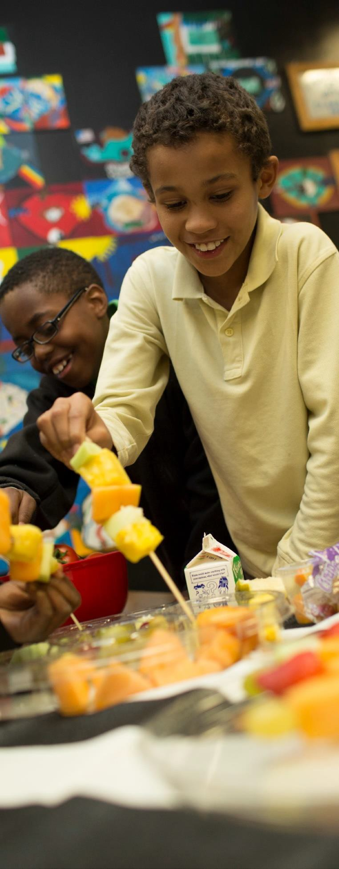
INTRODUCTION

Inviting Legislators to visit a Club in their state or district is a powerful way to engage elected officials and demonstrate the impact and value of your organization. Club site visits are the single best way to help elected officials (federal, state and local) and their staff understand the connections between the programs government dollars help fund and what’s happening at home. Site visits don’t have to be an arduous undertaking. The Boys & Girls Clubs of America’s Government Relations team is standing by, ready to help.
The resources in this toolkit can help you prepare for the visit, craft a message, and follow up with your Legislator after the visit.

Reach out to the Office of Government Relations, call 202-507-6670 or e-mail our Coordinator of Government Relations, Alex Knapp at Aknapp@bgca.org to let him know that you are planning to conduct a Club site visit with Members of Congress. You may also contact the Government Relations Director supporting State Alliances in your region regarding Club visits with State Legislators and local representatives. The Office of Government Relations is eager to help in any way – from brainstorming ideas to drafting materials to helping you work with the public official’s offices.

DEVELOP A PLAN
How can you best highlight Club programming for the member of Congress, State Legislator, local representative and/or staff person? Who should attend?

ISSUE THE INVITATION
Who is the best person to make the call or send the email to set up the visit? Provide the details of your proposed visit in a short letter or invitation which you can e-mail to their district or local office. Follow-up with a phone call and get the planning process underway.

CONDUCT THE VISIT
Once everything is arranged, conducting the visit is the easiest part. You’ll need to remain somewhat flexible, however, in case of unforeseen scheduling conflicts.

FOLLOW-UP
Let the Office of Government Relations know how the visit went and whether the elected official and/or staff person raised any questions that need a response. We can also assist with additional follow-up ideas to help build a lasting relationship with the office, your Club and your work with government dollars.
Your participation in this effort could make all the difference in our goal to increase support for Boys & Girls Clubs within Congress, State Legislatures and agencies.

CHECKLIST

for Arranging a Legislator Visit
STEP ONE

Pre-Planning
- Check in with the Office of Government Relations to let them know of your willingness to conduct a visit.

STEP TWO

Planning the Visit

- Identify what activity or program will best highlight your best programming or services made possible through public funding. [ex. Federal funding: Dept. of Ed 21st Century Community Learning Centers, USDA Meal and Snack Programs and DOJ Youth Mentoring. State funding: Temporary Assistance for Needy Families (TANF), state Dept. of Ed, state Dept. of HHS or equivalent].
- Identify specific dates and times to invite your public official for a visit.
- Who else will you have at the event? Legislators and their staff like to meet constituents, such as board members and parents. Consider including them in your visit.
- Consider inviting the media but only in coordina- tion with the elected official’s office.
- Schedule a meeting / phone call with Club per- sonnel who will be involved with the visit to ensure the plan – and any related advocacy messages
– are clear.*

STEP THREE
Invitation (template attached)

- If you don’t have it, call the Government Relations Team, (202) 507-6670 to get contact information for your Member of Congress or visit your State Legislature’s website for your State Legislators’ contact information.
- Ask your Legislator’s office who the best contact person is for an invitation for a visit in the district/state.
- Send the invitation to your Legislator.

STEP FOUR

Prepare for the Visit

- Coordinate with Club staff before the visit.
- Prepare a one page takeaway document or Impact Report telling your Club’s story including basic facts such as demographics, youth served, funding, programs and services, community partners, etc. Be sure to express in quantifiable terms the work you do with kids and teens.
- Assign a staff person the task of taking pictures during the visit as well as to take notes about any questions the elected official or staff person may have. This staff person could also share the visit on social media in real time.
- Assign a staff person the task of making sure a press release is emailed announcing the visit to your community paper or news site. The more local the paper or site, the more likely it will be covered.

STEP FIVE

Follow-Up and Sharing Your Impact Stories
- Send a “Thank You” letter including pictures and stories to the elected official’s office and to staff who participated within a week of their visit.
- Follow-up information on any questions raised during the visit.
- Follow-up on any potential media inquiries (after working with the elected official’s office).
- Use social media to share the visit and include photos.
- Be sure to share your impact by submitting photos and stories to Alex Knapp, Government Relations Coordinator at Aknapp@bgca.org and to the Government Relations Director in your region.

*Encourage the Member of Congress, State Legislator and/or staff to participate in Club programming with the kids.

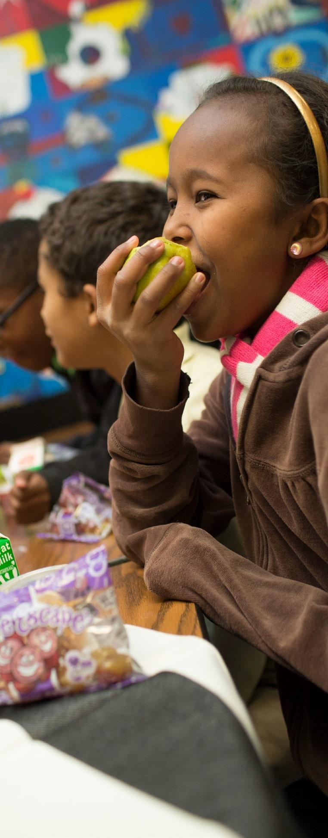
SCHEDULING / TIMELINE SAMPLE

SAMPLE CLUB VISIT PLAN

One hour visit

3:00pm - 3:05pm
Greet Legislator / staff at front office

3:05pm – 3:20pm
Club tour (learning center, gym, conference room, etc.)

3:20pm – 3:40pm
Meet the Club’s youth and participate in back-to- school, physical fitness or meal and snack programming.

3:40pm – 3:50pm
Wrap-up / final questions and comments

SAMPLE INVITATION

for Legislator Visit

FOR LETTER
[Date]

The Honorable [Full Name of Representative Here] Address
Washington, DC [Zipcode]

FOR EMAIL
TO: [Your Senator or Representative] ATTN: [In-District Scheduler]
FROM: [Your Name, City and State]
RE: [Boys & Girls Club of] Summer Feeding Program Visit DATE: [Current Date]

Dear Representative / Senator [Last Name]:

The Boys & Girls Clubs of [Club] is making a big difference for [state’s] children, and we would like to invite [Legislator] to visit our [Site name] to see it in action. Based on the [Legislator]’s travel schedule, we can work with your office to determine a date and time for the visit this summer.

[Add one paragraph that provides background information on your Club or program-related facts/stats.]

The Boys & Girls Clubs of [Club] is improving the lives of low-income children, and we hope we will have the opportunity to show this to you firsthand. Thank you for your service to our community and for your consideration of this invitation. If you have any questions you can contact me at:

Sincerely,
[Name of CPO or appropriate contact] Title
Email and phone number where they may reach you during the day.

DRAFT MEDIA ADVISORY

Media Contact: [Contact Name] [Agency Name] [Phone]
[Email]

[Agency Name] to Host [Senator/Representative Member Name] at [Club Name] [Add a second-line description about why visit/ program information.]
WHO/WHAT
[Name of major public officials who are participating, as well as the number of people who will be in attendance.]

[List and briefly describe any programs or activities that will take place. Concentrate specifically on the highlights.]

WHEN
[Date/Time]
[Be sure to mention individual start times for notable speakers/happenings.] WHERE
[Location/Address]

[Provide parking information, if relevant.]

WHY
[Provide an overview of the Club and the impact through programs on young lives.]

For more information, go to [your Club website].

EDITOR’S NOTE:
[Mention any opportunities for interesting visuals and tours. Provide onsite contact information.]

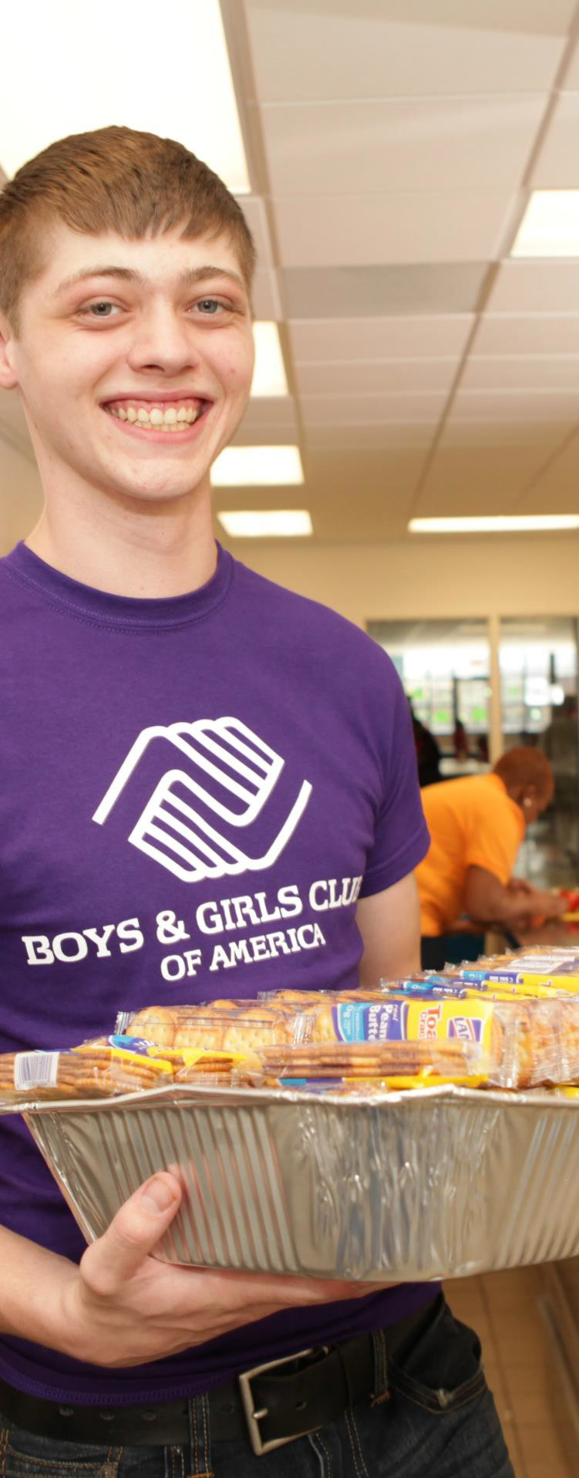
SAMPLE POSTS

for Twitter & Facebook

During the event
  - We’re here with @LegislatorJohnDoe in [CLUB] to talk about Club programs like [MENTION PROGRAMMING YOU HIGHLIGHTED DURING THE VISIT]!
@BGCA_Clubs [INCLUDE PHOTO]

  - Thank you @LegislatorJohnDoe for addressing the importance of Club Programs and #GreatFutures [INCLUDE LINK TO OP- ED/NEWS RELEASE/STATEMENT FROM CONGRESSMAN] @BGCA_Clubs

  - Excited to have @LegislatorJohnDoe join us at our [NAME OF EVENT OR PROGRAM] at [TAG CLUB HANDLE]! @BGCA_Clubs
#GreatFutures [INCLUDE PHOTO]

Following the event
  - A big thank you to @LegislatorJohnDoe for joining us to talk about the importance of Boys & Girls Clubs in [STATE/ DISTRICT/ LOCALITY]! @BGCA_Clubs [INCLUDE PHOTO]

  - Thank you @LegislatorJohnDoe for supporting #GreatFutures for [STATEians]!
@BGCA_Clubs

NOTE: If you include @BGCA_Clubs and
#GreatFutures our media team will help spread your story.

Example Press Clip from Club Visit

By Re-Essa Buckels | For WALB.com
Congressman Bishop meets with Boys & Girls Club leaders to discuss budget

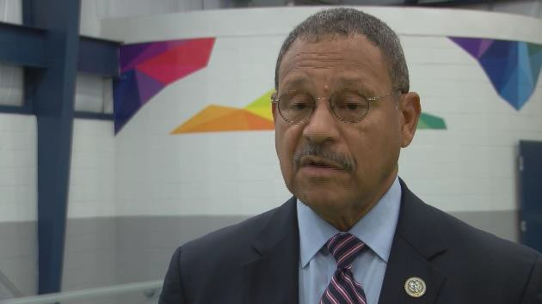
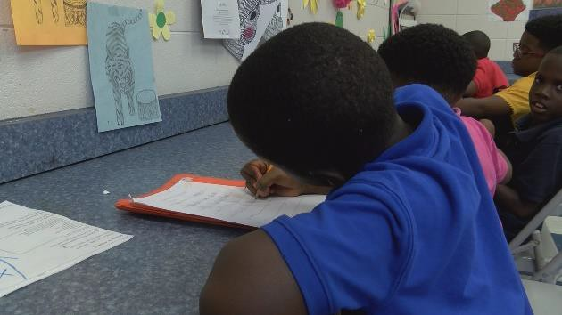
Officials with South Georgia's Boys & Girls Clubs said the proposed federal budget could hurt them.

Congressman Sanford Bishop held a town hall with the organization leaders to learn how President Trump's proposed budget could impact their members.

Every kid spends their first hour working on their lessons at Albany Boys & Girls Clubs.

But if President Trump's proposed 2018 federal budget passes, there may not be any place for kids to go after school hours.

"This is not just about Boys & Girls Club this is about the plight of young people," said Albany Boys & Girls Club President Marvin Laster.

And that's 3000 members in Albany alone.

"Some of these things that are being proposed are going to be detrimental not only to our young people, but detrimental to this region," remarked Laster.

Congressman Sanford Bishop toured the clubs and checked out the STEM classes.

"The director here reminded me that you've added an R to that which is STREAM to include reading which is so vitally important," explained Congressman Bishop.

He also witnessed the club's challenges after the storm.

Congressman Bishop then held a town hall on how Boys & Girls Club leaders can voice their concerns.

"The most dangerous times of the day for young people is between 3 and 8 at night," said Congressman Bishop.

He explained how $54 billion in discretionary funding could be cut in Trump's proposed budget. Of those cuts, the Department of Education would lose its 21st Century Learning Centers.

Laster said in 2015, the clubs received $60 million from the program.

"We know that we can count on him and he's a steadfast fighter," remarked Laster.

Laster is asking parents, partners and community leaders to voice their co ncerns about President Trump's proposed budget to their legislators.

Invitation Example

June 15, 2018

The Honorable Steny Hoyer
1705 Longworth House Office Building Washington, D.C. 20515

Dear Congressman Hoyer:

Thank you for your continued dedication to kids and teens in this country. You have been, and will always be, a true champion for our Boys & Girls Club kids and we know you learned some of those skills as a member in the Boys & Girls Club of Miami.

It is with great pleasure that we invite you to visit the Boys & Girls Clubs of Greater Washington, Wednesday, August 16th, 4:30pm at the Germantown Branch, 19910 Frederick Rd. Germantown, MD. During our visit we hope to highlight our Triple Play program, which is making a big difference for Maryland’s children. BGCGW uses this program to help kids learn about nutrition, healthy eating habits, staying fit, and creating better peer relationships.

Currently, one in five young people not only live in poverty, but are unlikely to graduate high school on time. Over 11.3 million young people are unsupervised after school, when juvenile crime escalates. Our clubs are open every day after school and during summer when kids need us the most. In our annual outcomes report, the National Youth Outcomes Initiative, 97% of our teens reported that they expect to graduate and 1 in 3 of our alumni surveyed say if it weren’t for their Club, they would have dropped out of school. We are supporting the youth of this great Nation and your admirable leadership and commitment to our effort directly improve the lives of millions of youth.

On behalf of the professionals, volunteers, and most importantly youth of Boys & Girls Clubs of Greater Washington, thank you for your support. We hope to see you in August.

Should you have any questions or require additional information, please contact me at (202) 507-6674 or slearn@bgca.org

Warm Regards,

Sage Learn
Director, Government Relations Boys & Girls Clubs of America

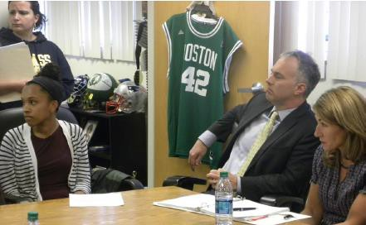
Examples of Highlighting a Club Visit on Social Media or in a Newsletter

Consider incorporating the visit into your next newsletter or email update:
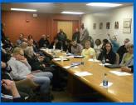
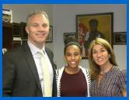

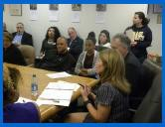 Governor’s Staff Visits - There has been numerous Community 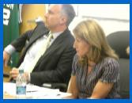 Forums held by the Governor’s office at several clubs throughout the state. These meetings and
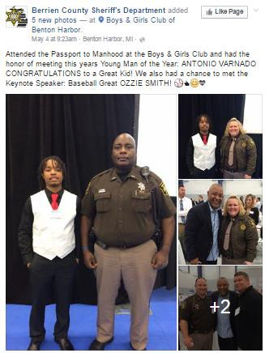
visits have been an excellent opportunity for them to see and hear firsthand the impact we have on the youth of this state. [The Mass Update]
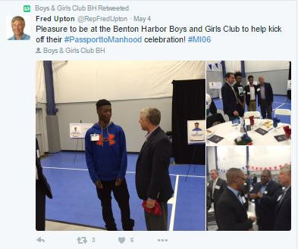

Post a photo or video of the visit through Twitter, Facebook & Instagram and be sure to share any media uploaded by your legislator about their time at the Club.

Protecting your Club during a political season

Inviting Elected Officials who are in an Election Cycle:
Because many club visits will occur in the window of time when Elected Officials are running for re- election, it is prudent to confirm logistics and remind them of our electioneering limitations prior to their visit, as to avoid any uncomfortable conversations later.

Sample Language to provide before Club Tour:
Thank you for agreeing to visit the [Club Name] in your district. We greatly appreciate your support and look forward to your upcoming visit to see all that we offer to put kids on the path to great futures.

[INSERT LOGISTICS AND REMINDERS FOR THE EVENT]

Please note: Because we are a tax-exempt organization under section 501(c)(3) of the Internal Revenue Code, it is our responsibility to ensure that we do not appear to endorse or support any candidate for public office or allow any political activity or electioneering in conjunction with our Clubs. In your official office capacity, we welcome you to share pictures or social media messages in conjunction with your visit, but please do not use them in election-oriented messages.

Again, we look forward to partnering with you on opportunities and possibilities for [State’s] youth.

Talking Points on policy issues
The Government Relations team is available to help you shape talking points that resonate with your Club or issues. Below are talking points we’ve used this year with elected officials. Feel free to use these examples as you prepare for your visit or call us for additional assistance at 202-507-6670.

BGCA GENERAL
- Boys & Girls Clubs serve 4 million youth at 4,300 clubs throughout the country, including 1,594 school-based Clubs, 990 Clubs in rural areas, 317 Clubs in public housing facilities, 481 affiliated youth centers on military installations worldwide, and 175 Clubs on Native lands.
- Afterschool and summer learning programs at Clubs keep young people safe, provide opportunities for improving academic success, building character and leadership skills, increasing health and fitness.
- For every $1 invested in a Boys & Girls Club $9.60 is returned to the community in current and future earnings and cost savings.
- Talk about how many families served by your Club and how many youth served in the state/district.
21st CCLC TALKING POINTS
- 21st CCLC funding supports before, afterschool and summer programs at Boys & Girls Clubs that provide youth with valuable resources such as tutoring, academic support & enrichment programs, STEM activities and physical activities.
- In 2016, 21st CCLC funding supported 650 sites at 234 Boys & Girls Clubs in 47 states.
- The 21st CCLC program is critical for working families, especially in underserved communities, improving academic achievement and keeping young people safe during after school hours when juvenile crime peaks.
- Talk about who you serve at your Club with 21st CCLC dollars and the impact your Club has locally.
- Support the 21st CCLC funding level of $1.3B for the FY 2019 Labor, Health and Human Services, and Education Appropriations. 21st CCLC is the only Federal funding dedicated to programming in the out-of-school time hours.
YOUTH MENTORING TALKING POINTS
- The Youth Mentoring Program has helped strengthen, expand and enhance mentoring programs for Club members in the following objectives: At-Risk Youth; Mentoring Native Youth; Delinquency and Gang Prevention; and Military Youth.
- BGCA’s National Youth Mentoring grant supports over 32,900 youth at Clubs in all 50 states and at overseas military installations.
- Talk about who you serve at your Club with OJP Youth Mentoring dollars and the impact your Club has locally.
- According to a three-year, DOJ-contracted study, Boys & Girls Clubs group mentoring approach results in a positive effect on youth’s social skills, and showed that preventing at-risk youth from pursuing delinquent behavior over the three year period provided a total maximum potential savings of $110 Million.
- Protect this critical program. Congress reduced this program by $10 million to $80 million in FY 2017, this is a major loss of vital programs for youth across the country in all 50 states.
- In order to serve more youth, support funding of $100 million for the Department of Justice National Youth Mentoring Program in the FY 2019 Commerce, Justice and Science Appropriations.
PERKINS ACT REAUTHORIZATION
- Boys & Girls Clubs across the country provide first job readiness and skills development for youth.
- Support the reauthorization of the Perkins Career and Tech Ed Act which provides funding to establish career pathways and training.
- We applaud the House bill H.R.2353 Strengthening Career and Technical Education for the 21st Century Act for explicitly including community based organizations as entities eligible to receive funding and expand eligibility to begin at 5th grade, an important time for starting to shape career preparation. We ask that this is included in the Senate bill as well.
- Additionally, we would like to see organizations with a national reach to local providers to be eligible for funding. Non-profits like BGCA have a network in all 50 states that touch virtually every community, can align funding where it is needed and provide technical assistance.

WORKFORCE DEVELOPMENT
- By 2020, 60 percent of jobs will require education and/or training beyond high school and if the lack of a skilled workforce is not addressed, the U.S. economy will face a shortage of 5 million workers.
- Today, 44% of employers say their greatest needs are in the area of soft skills (e.g. communication, customer service, creativity, collaboration, critical thinking).
- BGCA has the reach, the scale and the experience to be a key partner in preparing today’s youth for success in tomorrow’s workforce.
- Workforce Development is a national BGCA initiative to provide comprehensive workforce development programming -- job exploration, skill-building and transition programming that promotes a source of reliable workers, strengthens readiness for the workforce, and creates a talent pipeline for local and national businesses and organizations.
- Support $25 million administered by the Department of Labor’s Employment & Training Program dedicated to out-of-school time, youth-serving organizations providing career exploration, job skills development, work-based learning, and career mapping.
- A federal investment in partnership with BGCA could provide:
- Young adults with access to pre-apprenticeships.
- Teens with work-based learning experiences and career exploration.
- Youth with the necessary skills for success when entering post-secondary education and the workplace.
YOUTH DRUG/OPIOID PREVENTION
- Boys & Girls Clubs—whose hours are typically from 3pm to 6pm (or 8pm for teens)—are open during a time of day when youth are most likely to get involved in high-risk activity.
- Clubs provide a safe, caring environment while teaching youth important life skills, which helps increase youth resiliency, and reduces risk factors by employing key evidence-informed prevention strategies.
- Prescription drug use abstention is also higher among Club members compared to peers nationally:
- 92% of Club 9th graders report abstaining compared to 87% of ninth graders nationally
- 93% of Club 12th graders report abstaining compared to 80% of 12th graders nationally.
- Boys & Girls Clubs of America’s nationally acclaimed program, SMART Moves, addresses problems such as drug and alcohol use and premature sexual activity.
- Clubs are seeing unprecedented need with limited Federal funding currently going to youth opioid prevention in communities. Please support $25 million in FY19 for national, out-of-school time, youth-serving organizations providing prevention services and promoting resilience in children, families and communities.
TEMPORARY ASSITANCE FOR NEEDY FAMILIES (TANF)
- The TANF program is designed to help needy families achieve self-sufficiency. Boys & Girls Clubs are uniquely poised to partner and provide services to TANF-eligible youth because:
  - The high number of TANF eligible youth and families we serve
  - Clubs are a direct provider of services, accountable and effective
  - Clubs have Maintenance of Effort (MOE) match to offer
- We accomplish TANF goals by providing adult-supervised, safe and structured environment for TANF eligible children while their adult family member works or participates in work preparation activities.
- Support and protect the mandatory spending designated to the Temporary Assistance for Needy Families program.

MEAL & SNACK PROGRAM
- In 2015, Clubs reported serving more than 76.5 million snacks and meals at no cost to youth.
- Reauthorize the Child Nutrition Act, which includes the Summer Food Service Program and the Child and Adult Care Food Program, site-based meal programs that provide healthy meals and snacks to children during out-of-school times, while also supporting educational programs that keep children learning, engaged, safe and physically active.
- Club priorities in the bill are:
- Streamlined application: Reduce red tape by allowing organizations to submit one application to feed kids year round.
- Change the area eligibility to allow service to areas where 40% of youth are eligible for free/reduced meals (instead of 50%) this will feed more youth.
- Include critical start-up and expansion grants to help open and expand more sites.
- Provide the option of serving three meals so kids don't need to skip a meal.
- Please support the Summer Food Service Program and Child and Adult Care Food Program in the Child Nutrition Reauthorization.

RURAL IMPACT
- Boys & Girls Clubs are now the 2nd largest provider of afterschool programs in rural America—second only to public schools. 990 rural Clubs serve nearly 290,000 registered members, which is 1 out of every 3 young people in rural areas we serve.
- There is a tremendous demand for after-school programming in rural communities - more than 1.2 million children in rural areas participate in afterschool programs.
- Rural Clubs lack enough resources to expand and meet the growing needs of kids and teens in their communities. With many Clubs operating at capacity, for every child enrolled in an afterschool program, there are 3 waiting to get in.
BOYS & GIRLS CLUBS IN INDIAN COUNTRY
- Boys & Girls Clubs of Indian Country has 186 Native Clubs that serve nearly 90,000 youth in 27 states, representing over 100 different American Indian, Alaska Native and Hawaiian communities.
- Clubs in Indian Country provide innovative and culturally relevant programing targeting the unique needs of Native American youth.
- Support $14M for Methamphetamine and Suicide Prevention Initiative to help address the disproportionately high rates of suicide and substance abuse that Native youth face. We urge eligibility for this program to include national non-profits that can reach local native youth serving community organizations aligning funding where it is needed and provide technical assistance to local communities.
- Support funding for diabetes prevention through Indian Health Service, for youth to participate in Together Raising Awareness for Indian Life, a diabetes prevention program that uses an innovative combination of physical, educational, and nutritional activities.
MILITARY CONNECTED YOUTH
- Clubs provide 500,000 military connected youth at 480 sites with programs that positively impact their wellbeing and preparation for college or career.
- Support $15M for youth serving organizations for military kids. This will enhance our public private partnership, "Better Together" which deepens our impact with military connected youth, growing from 20,000 living off installation to 250,000 youth in the next five years.
STATE ALLIANCES
- The primary work of the 48 State Alliances of Boys & Girls Clubs includes: (1) promoting public awareness of youth development and the problems youth face throughout the state, and advocating for policy development and effective solutions; (2) promoting and strengthening Boys & Girls Clubs’ relationships with public and private agencies throughout the state; and (3) advocating for funds solely from the State and its agencies and political subdivisions to support local Club programs and services for youth across each state.
- Please contact the GR Director and/or Alliance Director (if applicable) in your state to obtain specific talking points for state government funding and policy strategies.

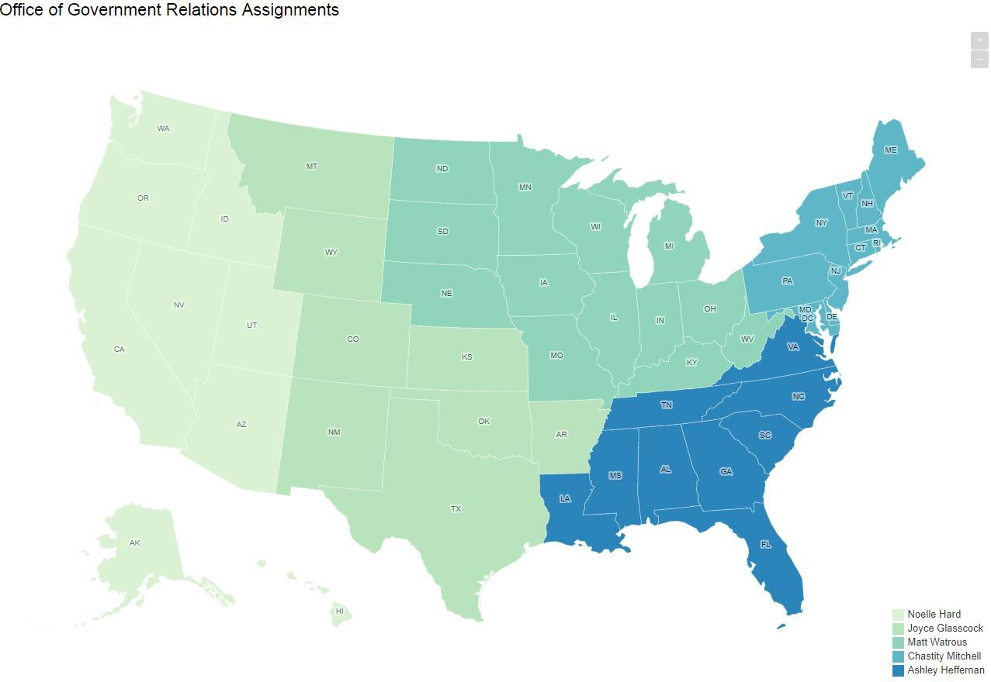
Contact List

Noelle Hardt:
PACIFIC: Alaska, Washington, Oregon, California, Hawaii, Idaho, Nevada, Utah, Arizona Nhardt@BGCA.org

907-947-8688

Joyce Glasscock:
SOUTHWEST: Montana, Wyoming, Colorado, New Mexico, Kansas, Oklahoma, Texas, Arkansas

Jglasscock@BGCA.org 785-341-4804

Matt Watrous:
MIDWEST: North Dakota, South Dakota, Nebraska, Minnesota, Iowa, Missouri, Wisconsin, Illinois, Michigan, Indiana, Kentucky, Ohio, West Virginia

Mwatrous@BGCA.org 616-552-9850
Ashley Heffernan
SOUTHEAST: Virginia, North Carolina, Tennessee, South Carolina, Louisiana, Mississippi, Alabama, Georgia, Florida Aheffernan@bgca.org

443-949-9312

Chastity Mitchell:
NORTHEAST: Maine, Vermont, New Hampshire, New York, Massachusetts, Connecticut, Rhode Island, New Jersey, Pennsylvania, Delaware, Maryland CMitchell@BGCA.org

615-305-0505

Alex Knapp
Washington, D.C., GR Office

Aknapp@BGCA.org 202-507-6670

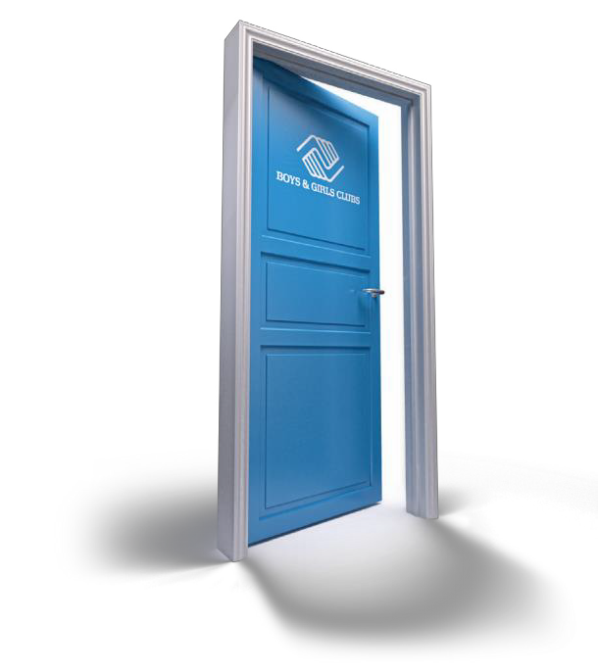

Office of Government Relations 1707 L St. NW, Ste. 670
Washington D.C. 20036

Tel: 202.507.6670
www.greatfutures.org

©2015 Boys & Girls Clubs of America • 2763-15

